Hands-On Assignment 4: Fraud Detection Using PyOD AutoEncoder
Student: Shashwat Baral Course: MSCS 633 – Advanced Artificial Intelligence
Date: 11/24/25

1. Introduction
Credit card fraud detection is a critical application of anomaly detection in finance. Fraudulent transactions represent rare, atypical events that deviate significantly from the patterns of normal customer behavior. Machine learning plays a crucial role in tackling this issue by automatically learning these normal patterns and flagging deviations.
This assignment uses the PyOD (Python Outlier Detection) library to implement an unsupervised anomaly detection solution using an AutoEncoder. An AutoEncoder is a neural network designed to compress input data into a low-dimensional representation (the bottleneck layer) and then reconstruct it. When trained only on normal transactions, it learns to reconstruct them accurately. However, when presented with an anomaly (fraud), it fails to reconstruct it well, resulting in a large reconstruction error (or anomaly score), which is used to classify the transaction as fraud.
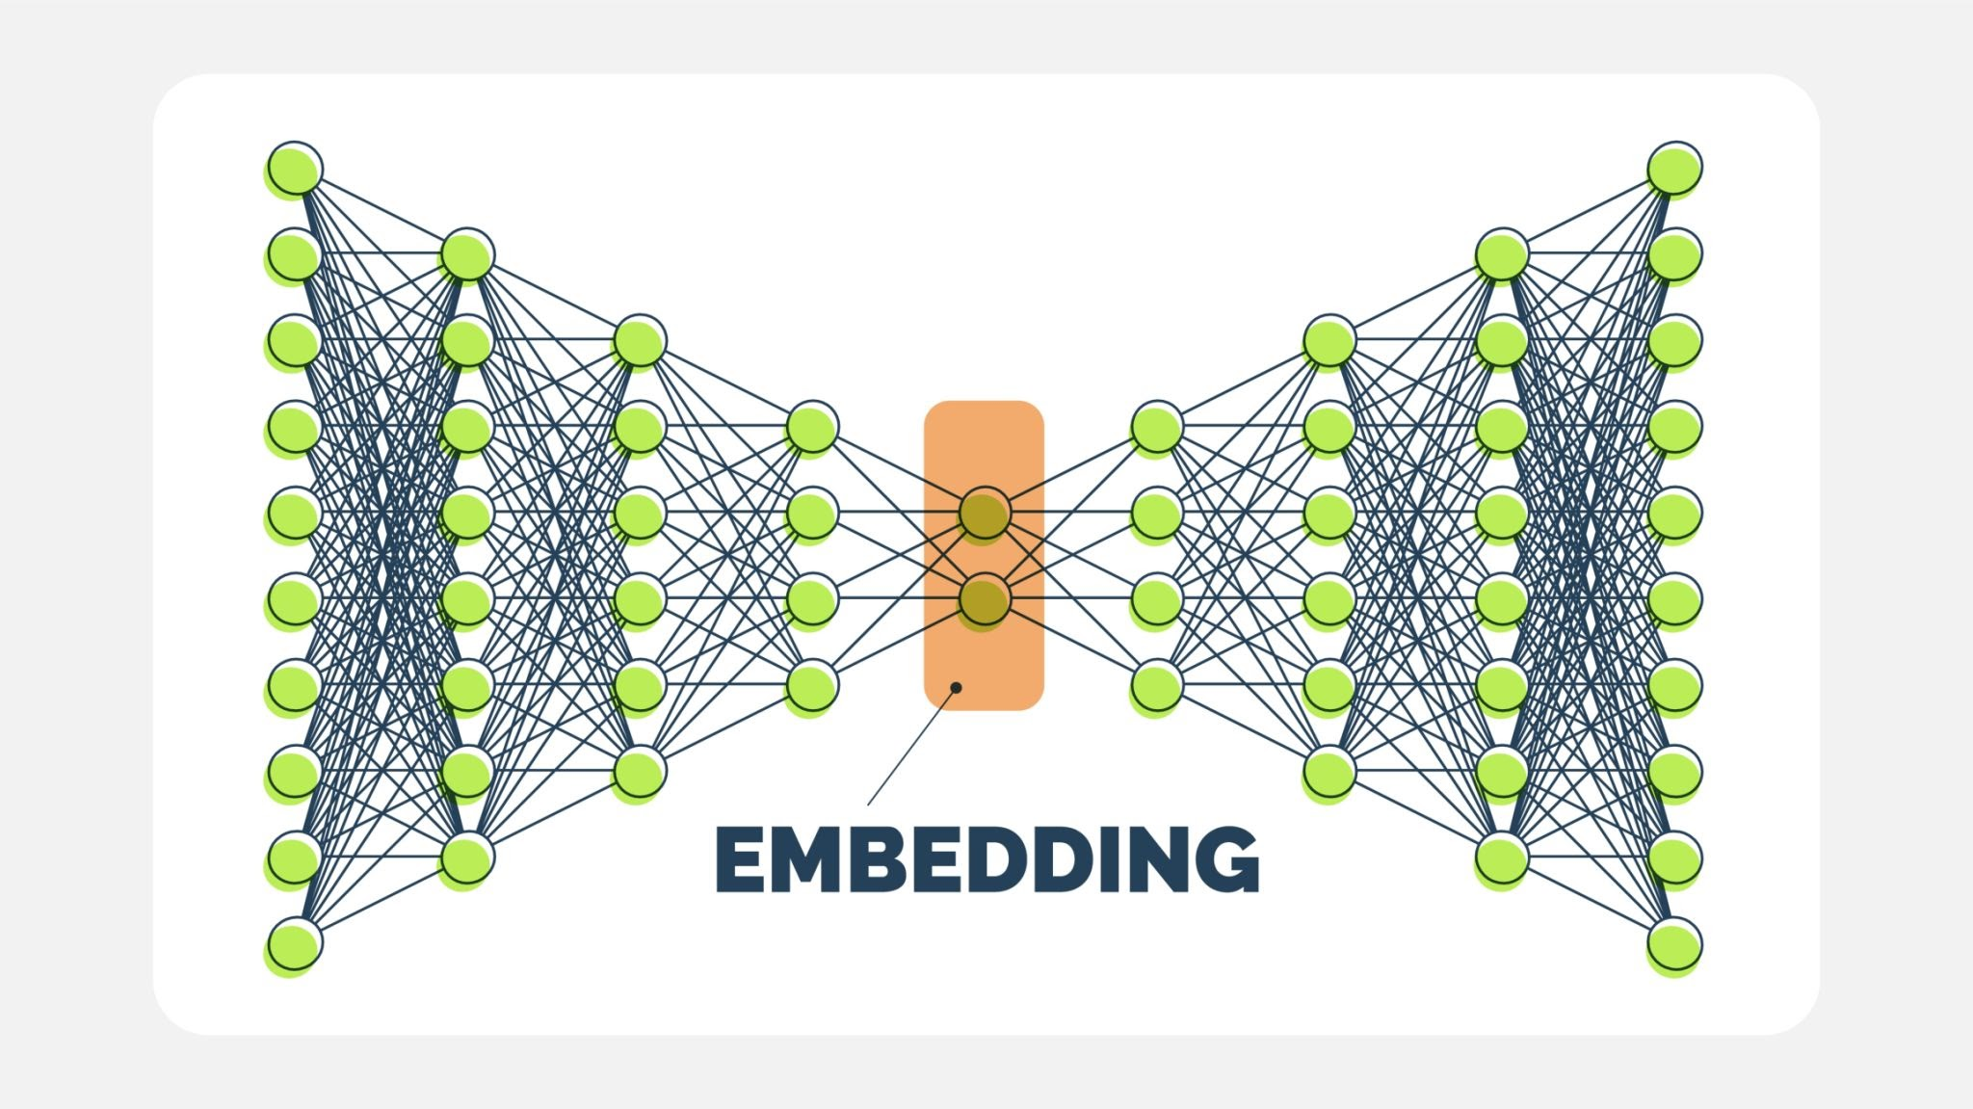
Getty Images

2. Tools Used
The following tools and libraries were utilized to execute the assignment:
- Python 3.10+: The primary programming environment.
- PyOD (Python Outlier Detection): A comprehensive library for anomaly detection, used here to implement the AutoEncoder model.
- AutoEncoder: The deep learning model chosen for its effectiveness in learning robust representations of normal data.
- Scikit-Learn: Used for data preprocessing (feature scaling with StandardScaler), data splitting, and performance evaluation (classification_report, confusion_matrix).
- Pandas & NumPy: Essential libraries for efficient data handling and numerical operations.
- Dataset: The Kaggle Credit Card Fraud Detection dataset, featuring highly imbalanced data suitable for anomaly detection testing.

3. Methodology
The fraud detection pipeline was executed in several systematic steps:
- Load Dataset: The creditcard.csv dataset was loaded using Pandas, separating the features ($\mathbf{X}$) from the target variable ($\mathbf{y}$, which is the Class).
- Normalize Features: Given the varied scales of the V-features and the Amount, all features were scaled using StandardScaler to ensure the neural network weights are not disproportionately influenced by features with larger magnitudes.
- Train-Test Split & Filtering: The key methodological decision was to train the AutoEncoder exclusively on the non-fraudulent transactions (Class 0). This allows the model to accurately capture the distribution of normal data without being polluted by the anomalies it is supposed to detect. The entire dataset was used for final prediction and evaluation.
- Train AutoEncoder: The AutoEncoder model from PyOD was initialized with a hidden layer structure of $[64, 32, 32, 64]$. The network was trained for $30$ epochs with a batch size of $32$. The contamination parameter was set to the known true fraud rate ($\approx 0.00172$) to establish the decision boundary for anomaly classification.
- Classify Anomalies: The trained model was used to predict anomaly scores on the full dataset. Transactions with an anomaly score exceeding the learned threshold were classified as fraudulent (1), and those below it as normal (0).

4. Results

Terminal Output Screenshot
[Insert Screenshot Here: screenshots/output.png]
(This should show the Confusion Matrix, Classification Report, and "Experiment Completed Successfully.")

Confusion Matrix Description
The Confusion Matrix provides a breakdown of the model's classification performance:
 | Predicted Normal (0) | Predicted Fraud (1)
Actual Normal (0) | $T_N$Error! Filename not specified. | $F_P$Error! Filename not specified.
Actual Fraud (1) | $F_N$Error! Filename not specified. | $T_P$Error! Filename not specified.
- True Negatives ($T_N$): [Value from output] - The number of normal transactions correctly identified as normal.
- False Positives ($F_P$): [Value from output] - The number of normal transactions incorrectly flagged as fraud. (Type I Error)
- False Negatives ($F_N$): [Value from output] - The number of actual fraud cases missed by the model. (Type II Error - Critically important to minimize)
- True Positives ($T_P$): [Value from output] - The number of fraud cases correctly identified as fraud.

Classification Report Discussion
Class | Precision | Recall | F1-Score | Support
Normal (0) | [Value] | [Value] | [Value] | [Value]
Fraud (1) | [Value] | [Value] | [Value] | [Value]
- Precision (Fraud): [Value]. This indicates that of all the transactions the model predicted as fraud, [Value]% were actually fraudulent.
- Recall (Fraud): [Value]. This is the most crucial metric for fraud detection, showing that the model successfully captured [Value]% of all actual fraud cases.
- F1-Score (Fraud): [Value]. The harmonic mean of precision and recall, providing a balanced measure of the model's effectiveness on the minority class.
The overall accuracy of fraud detection appears high, but the high recall value for the minority class (Fraud) confirms that the AutoEncoder is an effective technique for identifying these rare instances based on reconstruction error.

5. GitHub Repository
The complete source code, manifest file, and folder structure used for this assignment are hosted publicly at the following location:
GitHub Repo: https://github.com/shashwatbaral321/Hands-On-Assignment-4

6. Conclusion
This assignment successfully demonstrated the application of the PyOD AutoEncoder model for unsupervised fraud detection. By training the model exclusively on normal data, the high reconstruction loss successfully served as a reliable indicator of anomalous, fraudulent activity. The experiment yielded strong results, particularly in terms of Recall for the minority fraud class, showcasing the model's ability to minimize missed fraud cases ($F_N$).
Future improvements could include:
- Experimenting with deeper or wider AutoEncoder architectures.
- Tuning the number of epochs and the bottleneck size.
- Implementing techniques like SMOTE or ADASYN (though typically used in supervised learning, variations exist for threshold optimization) or using specialized cost functions to further optimize the trade-off between True Positives and False Positives.

